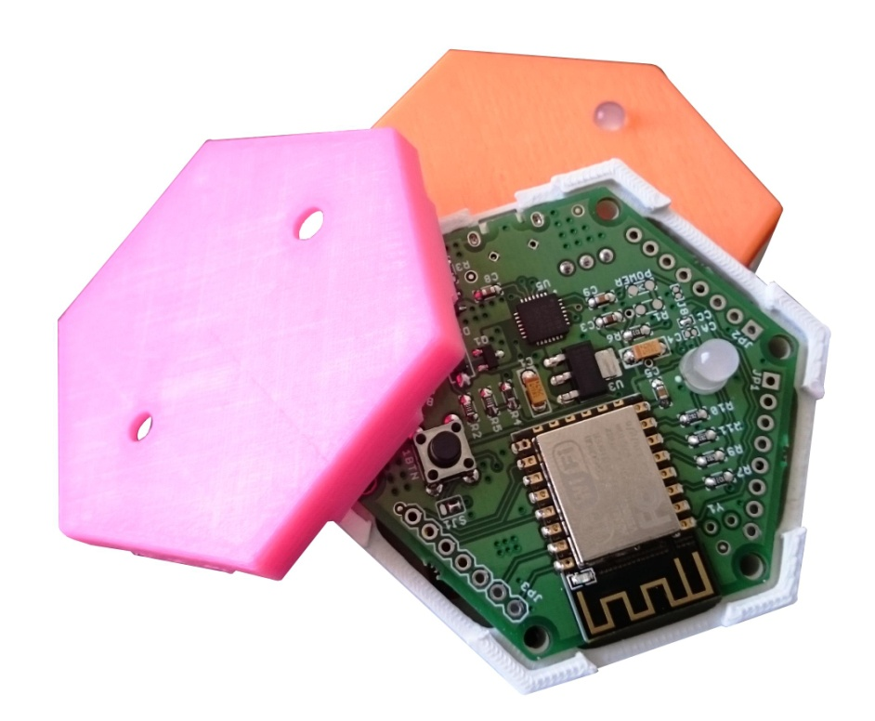**1btn in making…**

First of all thanks to all the backers for sincere support to the project and making large batch production of 1btn feasible.

While we kept campaign goal to be $1 to make 1btn, no matter what, we were secretly hoping for orders of at least 100 units. And we are happy to tell you that we stand at about 122 orders till date; and they still counting.

**MANUFACTURING PLAN AND CURRENT STATUS**

Most of the things were set in motion while we were in last sprint of the campaign. This helped us in starting things earlier than planned.

As of today component sourcing is 100 % complete. 3D printing of enclosures is in progress; and it’s about 80% complete while we release this update. 1btn enclosures are getting 3D printed at our manufacturing partner’s workshop in Pune, India.

PCB assembly and programming is in progress too and about 40% of the work is done. PCBA is also being done in Pune, India.

Since most of the parts are locally sourced and manufactured, we have now full control over the entire process and so the timeline and costs.

While we already have created framework for web-service for 1btn usage, API creations and webservice modifications in progress for development partners to take up further application development on. Last few minor changes are being done before we release it to our development partners for experimentation.

In a nutshell, so far everything is on track and we are in control of the timeline.

**WHAT WILL HAPPEN THIS MONTH?**

We are positive that later this month we will be dispatching units for development partner backers. By end of the month some more upgrades in webservice would be done.

We will also update github repo with minor changes in designs that we did during manufacturing of 1btn PCBA.

All backers would be contacted for address verification later this month. This is to ensure that your 1btn can reach to you in time when dispatched.

**UNTIL YOU RECEIVE YOUR PLEDGES…**

We are making a few extra 1btn units to fulfill pre-orders as well as orders after that; so please get the word out and let everyone know if they still wish to grab one.

In the meantime, feel free to write to us and make suggestions; lend us a helping hand, if you can, in writing more and more use cases of 1btn.